UNU Commitment Ledger Setup – D1

Area | Module | Activity | Migration Requested | Accomplished Via
Configuration | GL | Detail Ledger | N | Online change
Configuration | GL | Detail Ledger Group | N | Online change
Configuration | GL | Ledgers For A Unit | N | Online change
Configuration | GL | Open Periods Update | N | Online change

Detail Ledgers | Detail Ledger Definition
Navigation:  General Ledger > Ledgers > Detail Ledgers  Add a new Detail Ledger  SetID – SHARE  Ledger – UNU_COMMIT  Description – UNU Commitment Ledger  Ledger Template - STANDARD | 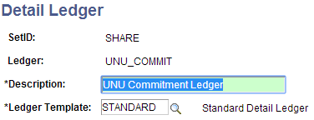

Ledger Groups | Ledger Group Definition
Navigation:  General Ledger > Ledgers > Ledger Groups  Add a new Ledger Group  SetID – SHARE  Ledger – UNU_COMMIT  Description – UNU Commitment Ledger  Ledger Template - STANDARD | 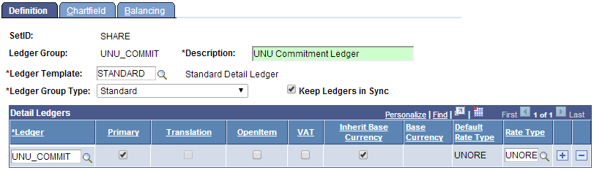  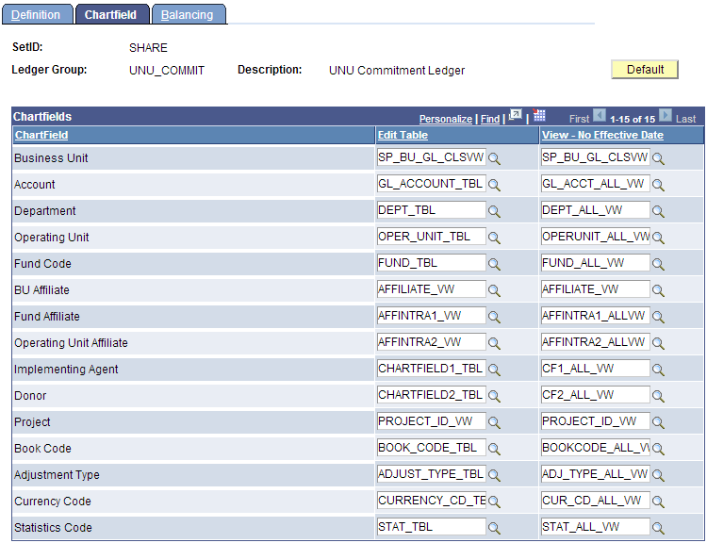
Note the Balancing options selected. | 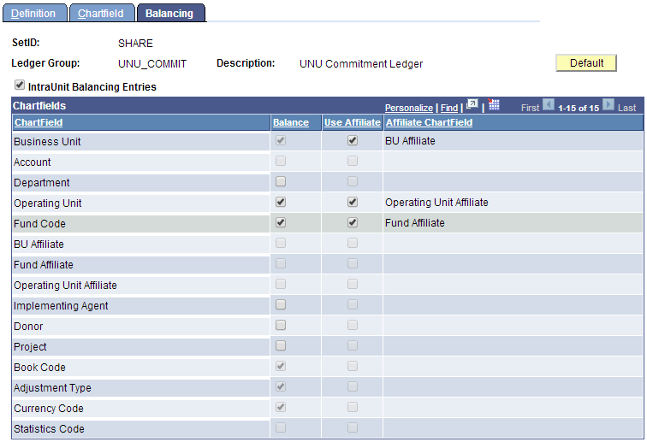

Ledgers For A Unit | Ledgers For A Unit Definition
Navigation:  Set up Financials/Supply Chain > Business Unit Related > General Ledger > Ledgers For A Unit  Modify GL BU UNUNI definition  Add new Ledger Group UNU_COMMIT | 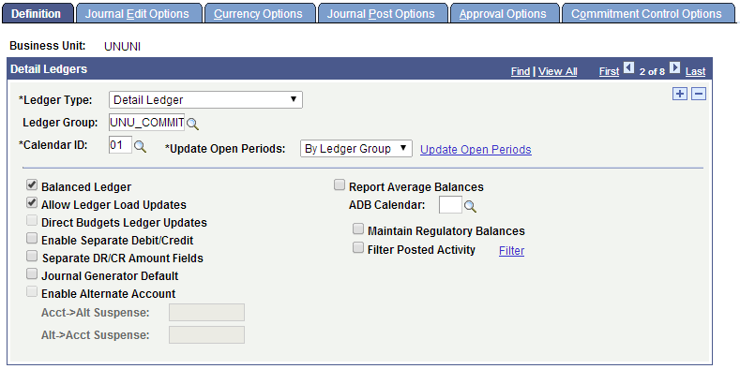  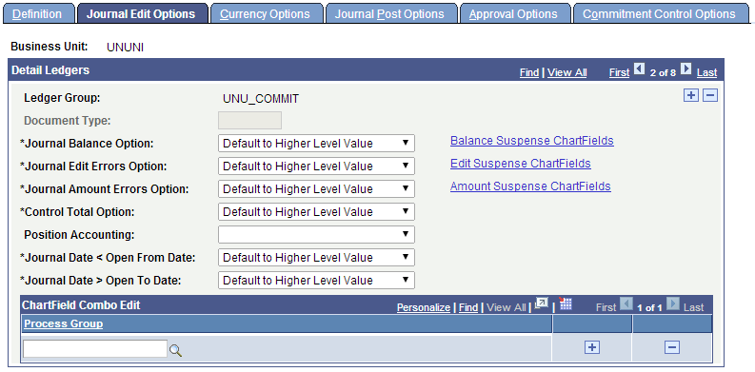  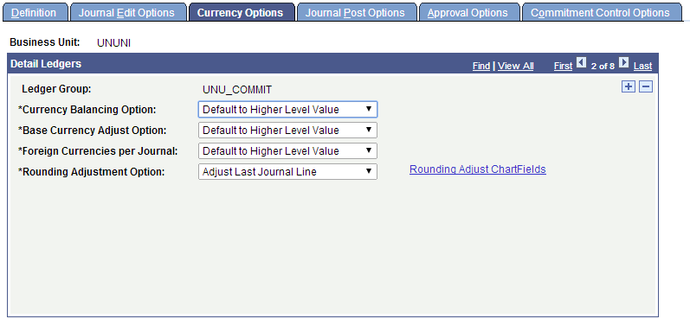
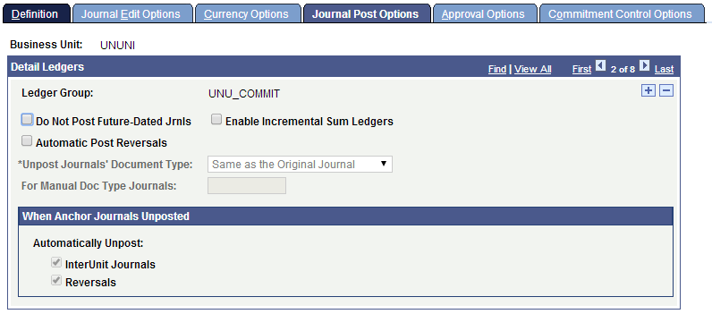
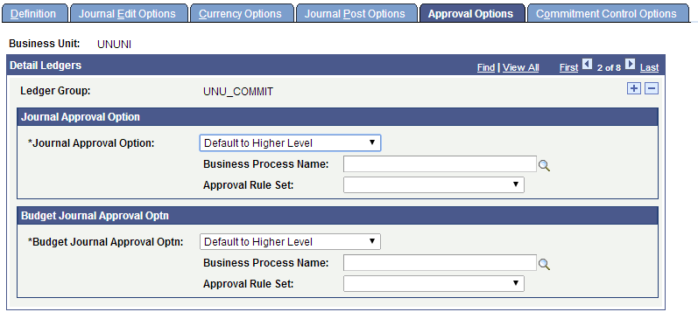
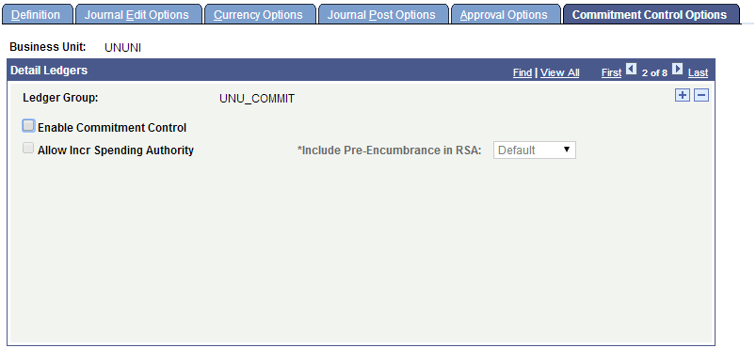

Open Period Update | Open Periods
Navigation:  Set up Financials/Supply Chain > Business Unit Related > General Ledger > Open Periods > Open Period Update  Update Open Periods for following combination: GL/UNUNI/UNU_COMMIT | 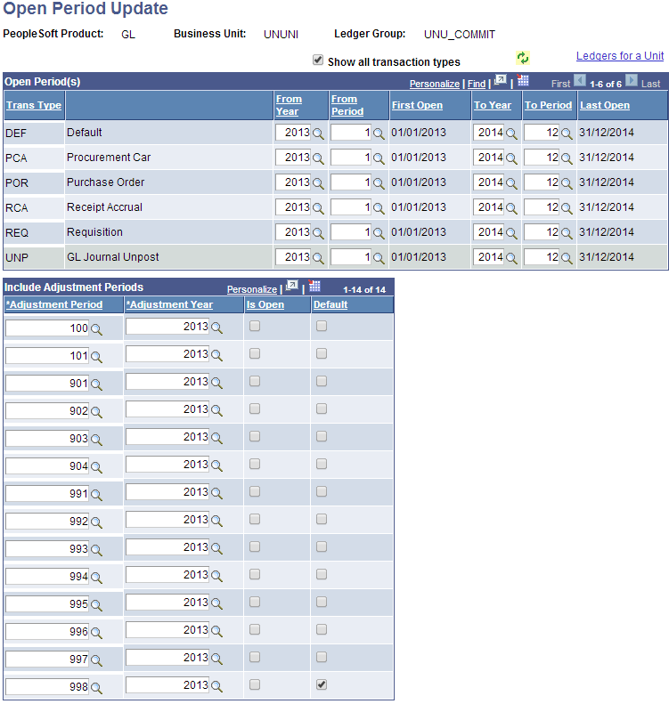

Query Manager | Create New Query
Navigation:  Reporting Tools > Query > Query Manager  Create New Query: UNU_PO_ACT_SUMM_REPORT | 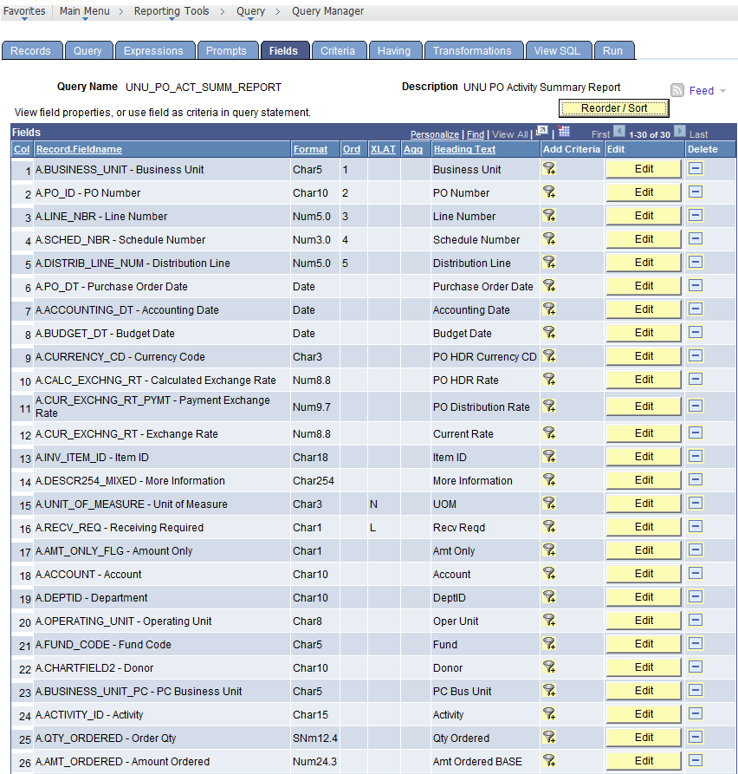  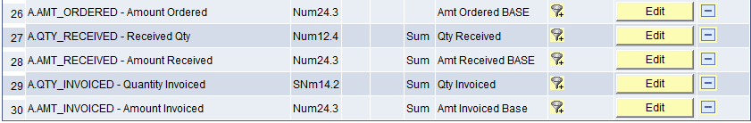  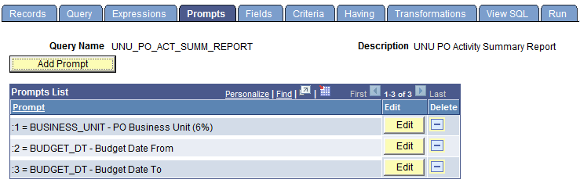
Actual PSQuery Output | 